**STEPS TO INSTALL REACT JS**

* Download node js from google chrome - <https://nodejs.org/en/download/>

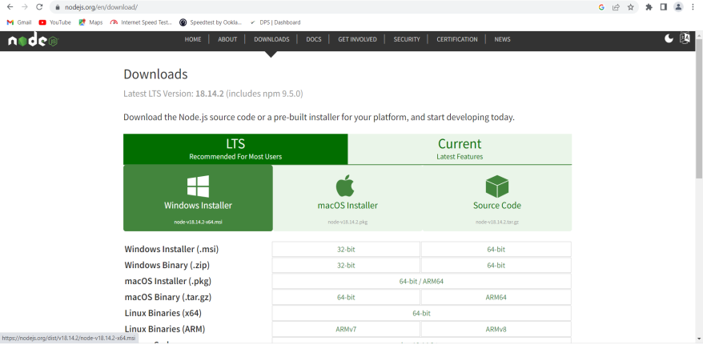

* **Open the Downloaded file from your PC**
* Accept the terms and conditions. Click Next
* Do not modify the Destination Folder. Click Next
* Do not modify the Custom Setup. Click Next
* Tools for Native Modules. Click Next
* Click to Install. And wait until to Finish.
* After successful installation click Finish
* **Open Command Prompt**
* Enter node –version

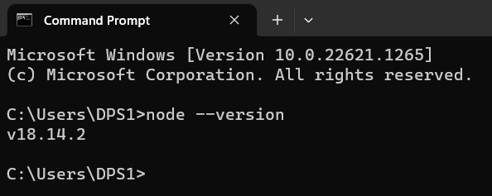

* If it is showing node version then node js is installed successfully.
* **Create folder in Local Disk (C:)**
  + Give a folder name as My Project
* **Open Command Prompt inside the My Project folder**
* Enter npm –version and press enter
* Enter npx create-react-app **myfirstreactapp**
* Ok to proceed? (y) press y
* Wait until to display at the end of the screen **Happy hacking!**
* Enter cd myfirstreactapp same command prompt
* Enter npm start
* **Windows Security Alert**
* Give Access public network – Click Allow access
* **To update the version of node js**
* Open cmd and type node -v( to get the current version)
* Type npm install -g n (installs a module named n which enables user to update)
* n latest (updates to latest version)
* node -v (to see the updated version)